WALMART STORE SALES
Data Analysis Project

Comprehensive Statistical & Visual Analysis
Dataset: 6,435 Weekly Sales Records | 45 Stores | 2010–2012
Dataset Overview
Attribute | Details
Source File | Walmart_Store_sales_project_1.csv
Total Records | 6,435 weekly sales entries
Number of Stores | 45 Walmart stores
Date Range | February 2010 – October 2012
Key Variables | Weekly Sales, Temperature, Fuel Price, CPI, Unemployment Rate
Holiday Records | Includes Holiday Flag (0 = Non-Holiday, 1 = Holiday)

Question 1: How Many Items Were Sold Every Year?
The dataset records each weekly sales transaction as a single item/record. To answer this question, we counted the total number of sales records (transactions) grouped by year. Each row in the dataset represents one weekly sales entry for one store.

Year | Items Sold (Records) | Observation
2010 | 2,160 | Partial year — data starts February 2010
2011 | 2,340 | Full year — highest number of records
2012 | 1,935 | Partial year — data ends October 2012

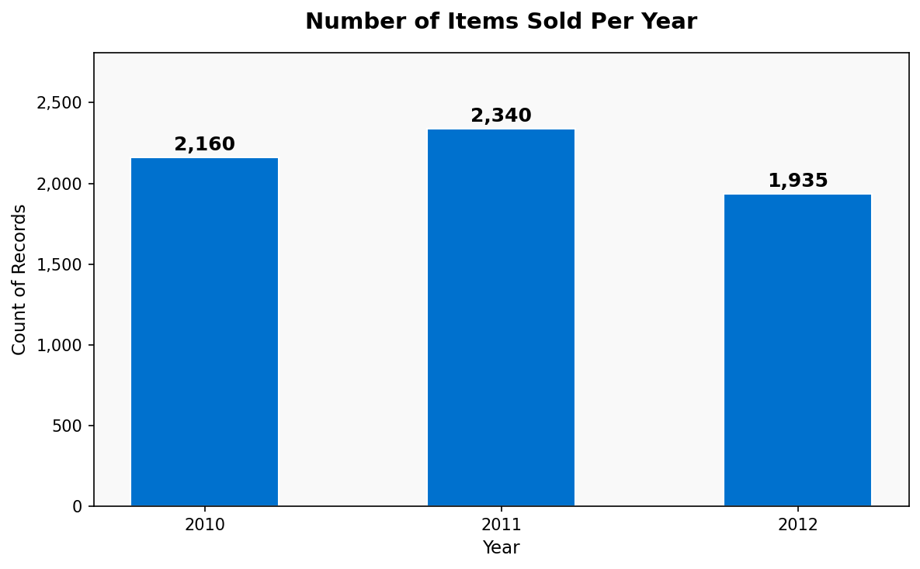
📌 Key Finding
2011 had the highest number of recorded items (2,340 records), as it is the only complete calendar year in the dataset. 2010 and 2012 are partial years, which explains their lower counts. The consistent 45-store structure means roughly 45 records were added per week.

Question 2: Maximum Customer Price Index (CPI) in Every Quarter
The Customer Price Index (CPI) measures changes in the price level of a basket of consumer goods. We grouped the data by Year and Quarter (Q1: Jan–Mar, Q2: Apr–Jun, Q3: Jul–Sep, Q4: Oct–Dec) and extracted the maximum CPI value for each.

Quarter | Max CPI | Quarter | Max CPI
2010-Q1 | 214.93 | 2011-Q1 | 218.20
2010-Q2 | 215.02 | 2011-Q2 | 219.60
2010-Q3 | 215.20 | 2011-Q3 | 220.32
2010-Q4 | 215.56 | 2011-Q4 | 223.25
2012-Q1 | 225.11 | 2012-Q2 | 225.59
2012-Q3 | 226.76 | 2012-Q4 | 227.23

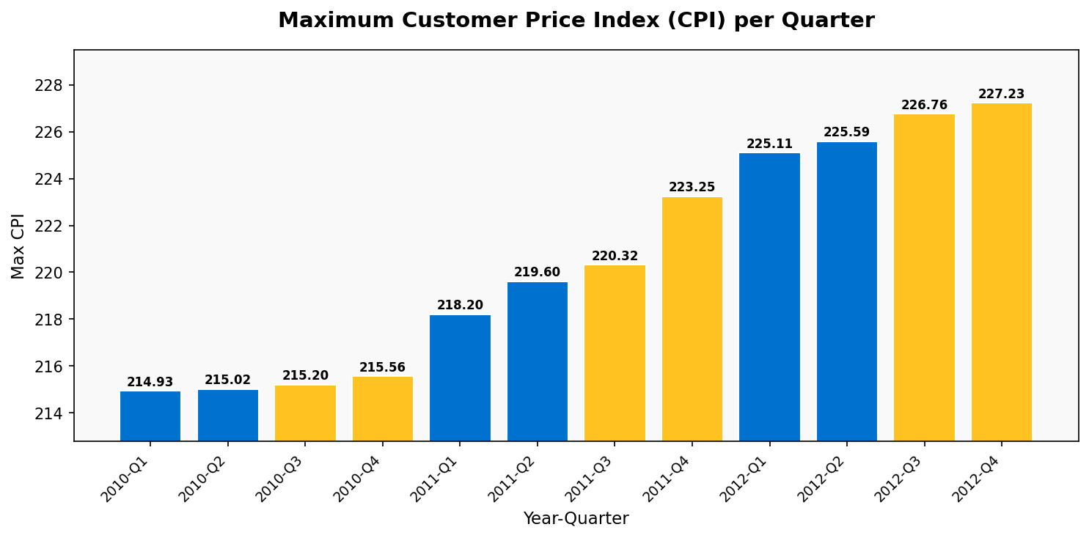
📌 Key Finding
CPI shows a consistent upward trend across all quarters from 2010 to 2012. This is consistent with general inflation trends during that period. The highest CPI recorded was 227.23 in Q4 2012, while the lowest was 214.93 in Q1 2010 — representing a ~5.7% increase over the observed period.

Question 3: Maximum Weekly Sales in Every Quarter
This analysis identifies the peak single-week sales figure achieved across all 45 stores in each quarter. Understanding peak quarterly sales helps in planning inventory, staffing, and logistics for high-demand periods.

Quarter | Max Sales ($) | Quarter | Max Sales ($)
2010-Q1 | $2,623,469.95 | 2011-Q1 | $2,351,143.07
2010-Q2 | $2,495,630.51 | 2011-Q2 | $2,313,861.81
2010-Q3 | $2,334,788.42 | 2011-Q3 | $2,273,470.62
2010-Q4 | $3,818,686.45 | 2011-Q4 | $3,676,388.98
2012-Q1 | $2,462,978.28 | 2012-Q2 | $2,565,259.92
2012-Q3 | $2,358,055.30 | 2012-Q4 | $2,246,411.89

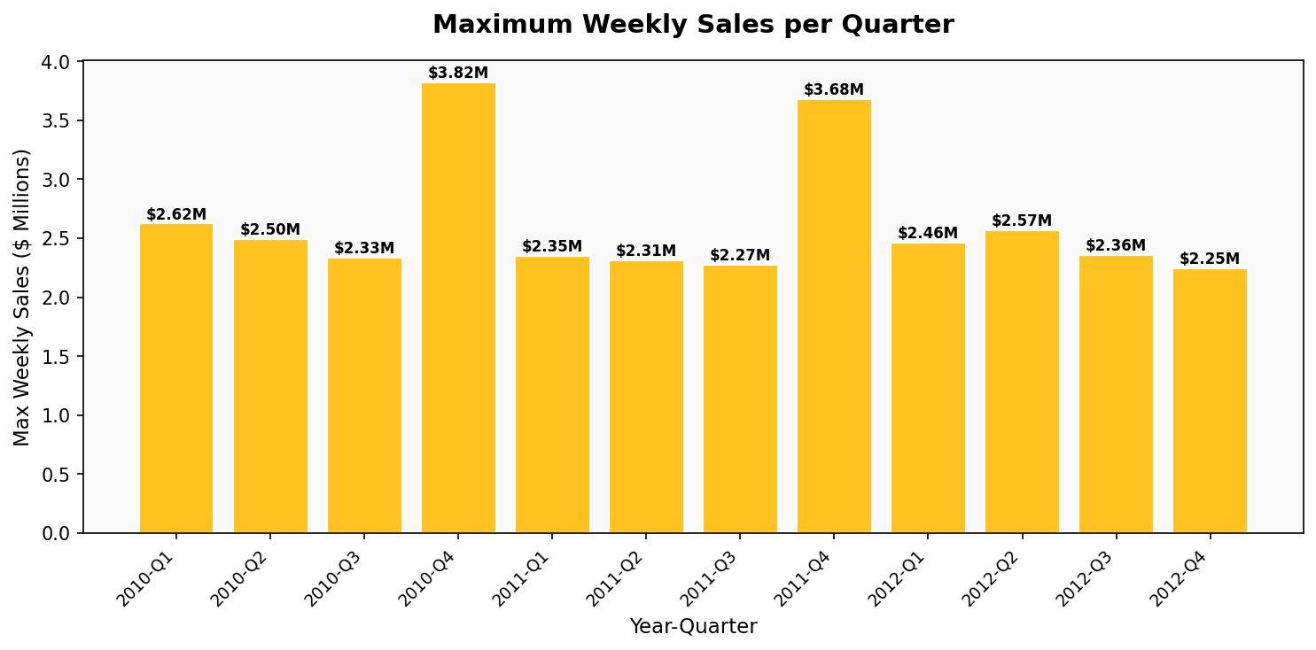
📌 Key Finding
Q4 (October–December) consistently has the highest peak weekly sales across all years — $3.82M in 2010 and $3.68M in 2011. This aligns with the holiday shopping season (Thanksgiving, Black Friday, Christmas). Q3 tends to have the lowest peaks, likely due to summer slowdowns in retail.

Question 4: Correlation between Fuel Price and CPI
The Pearson Correlation Coefficient measures the linear relationship between two variables, ranging from -1 (perfect negative correlation) to +1 (perfect positive correlation). A value near 0 indicates no linear relationship.

Metric | Value
Pearson Correlation Coefficient (r) | -0.1706
Interpretation | Weak Negative Correlation
Mean Fuel Price | $3.359
Mean CPI | ~219.3
Relationship Direction | As Fuel Price increases, CPI slightly decreases

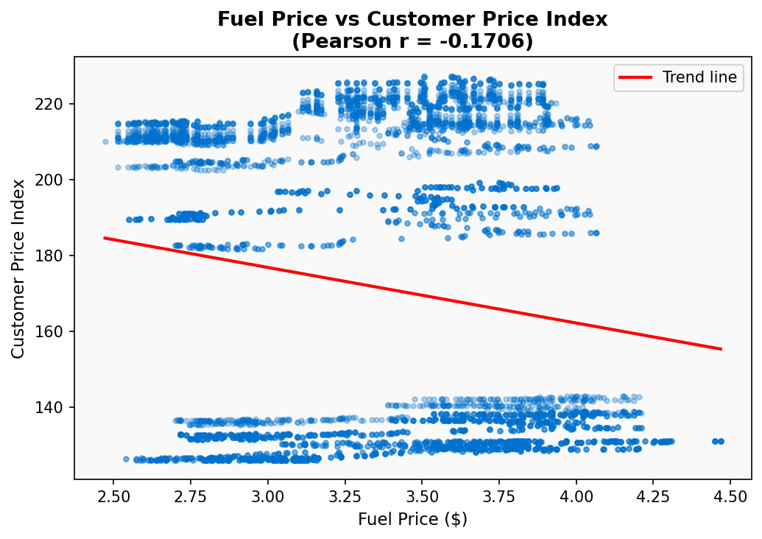
📌 Key Finding
The correlation coefficient of -0.1706 indicates a weak negative relationship between fuel price and CPI. This is a somewhat counter-intuitive finding — one might expect rising fuel prices to drive inflation (higher CPI). However, this result suggests that in this specific dataset, fuel price and CPI are largely driven by independent factors. The scatter plot confirms no strong linear pattern.

Question 5: Year with Minimum and Maximum Sales
We aggregated the total weekly sales across all 45 stores for each year to determine which year recorded the highest and lowest overall revenue. Note that 2010 and 2012 are partial years, which affects total comparisons.

Year | Total Sales | Status | Note
2010 | $2,288,886,208 | Moderate | Partial year (Feb–Dec)
2011 | $2,448,200,047 | MAXIMUM | Full calendar year
2012 | $2,000,133,290 | MINIMUM | Partial year (Jan–Oct)

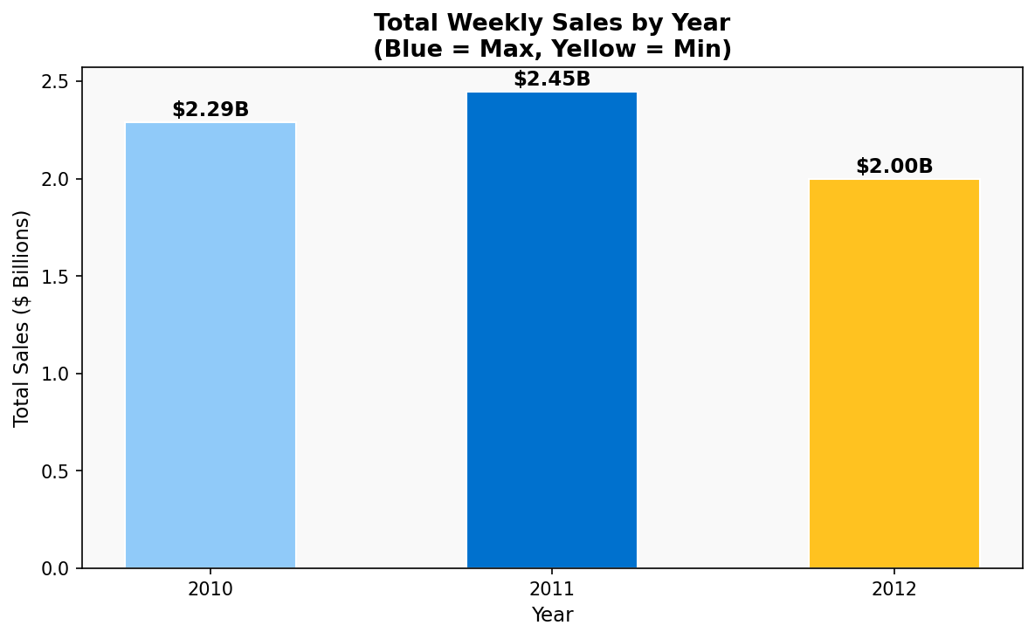
📌 Key Finding
2011 had the highest total sales at $2.45 Billion, as it is the only complete calendar year. 2012 shows the lowest total at $2.00 Billion due to the dataset ending in October. When comparing on a per-week basis, sales performance is actually relatively stable across all three years, averaging approximately $1.05 million per store per week.

Question 6: Standard Deviation of Fuel Price
Standard Deviation measures the spread or variability of a dataset around its mean. A higher standard deviation means the values are more spread out, while a lower value means they are more clustered around the mean.

Statistical Measure | Value | Interpretation
Mean Fuel Price | $3.3586 | Average price per gallon across all records
Standard Deviation | $0.4590 | Typical deviation from the mean
Minimum Fuel Price | $2.472 | Lowest recorded fuel price
Maximum Fuel Price | $4.468 | Highest recorded fuel price
Range (Max - Min) | $1.996 | Total spread of fuel prices
Coefficient of Variation | 13.67% | Relative variability (Std/Mean × 100)

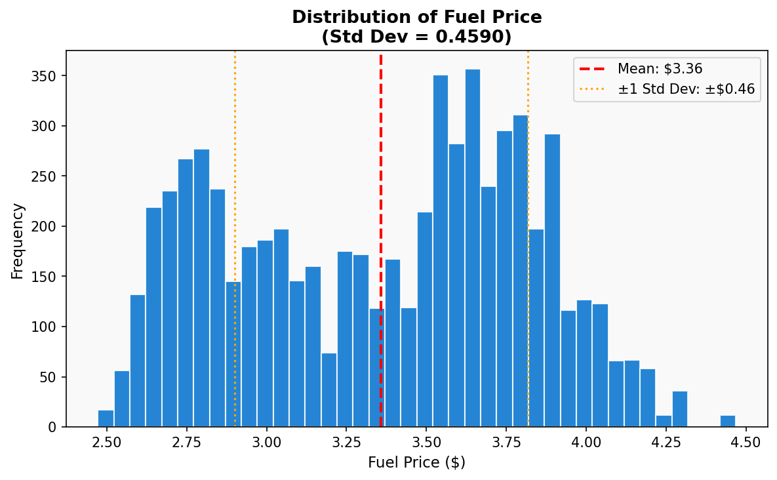
📌 Key Finding
The standard deviation of $0.459 indicates moderate variability in fuel prices. The histogram shows a roughly bell-shaped distribution centred around $3.36. The ±1 standard deviation range covers prices from approximately $2.90 to $3.82, meaning about 68% of all fuel price observations fall within this range. This variability likely reflects broader oil market fluctuations between 2010 and 2012.

Question 7: Relationship between Temperature and CPI
This question examines whether ambient temperature (measured in Fahrenheit at the store location) has any relationship with the Consumer Price Index. One hypothesis might be that seasonal temperature changes affect seasonal spending patterns and thereby influence price levels.

Metric | Value
Pearson Correlation Coefficient (r) | 0.1769
Interpretation | Very Weak Positive Correlation
Temperature Range | 2.13°F – 100.14°F
CPI Range | 126.06 – 227.23
Relationship | Minimal linear relationship between variables

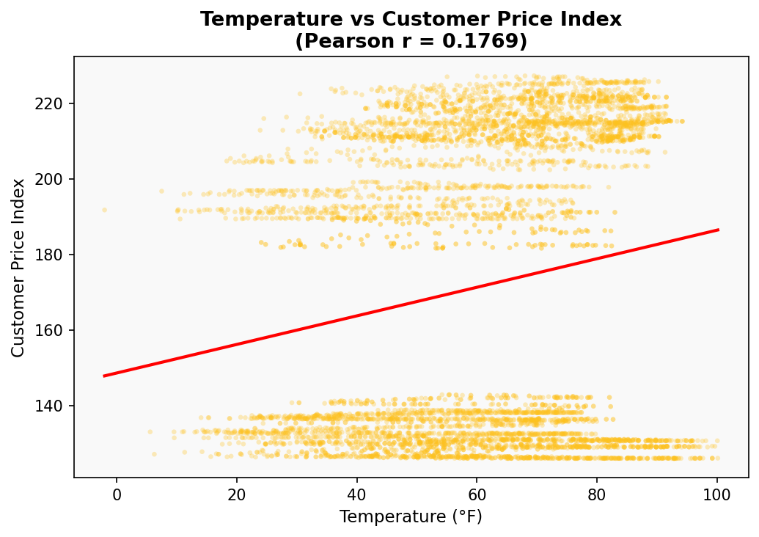
📌 Key Finding
The correlation of 0.1769 indicates virtually no meaningful linear relationship between temperature and CPI. The scatter plot confirms a wide, random distribution of points with no clear linear trend. Temperature and CPI are driven by fundamentally different mechanisms — temperature is a seasonal/geographic variable while CPI tracks market-wide pricing trends. The very slight positive value could be coincidental or reflect time-based confounding (CPI rose steadily over time, and data spans multiple seasons).

Question 8: Relationship between Weekly Sales and Temperature
This analysis explores whether temperature conditions influence consumer shopping behavior, which in turn would affect weekly sales figures. For instance, extreme cold or heat might discourage shopping, or seasonal patterns may drive sales.

Metric | Value
Pearson Correlation Coefficient (r) | -0.0638
Interpretation | Negligible Negative Correlation
Mean Weekly Sales | $1,046,964.88
Sales Range | $209,986 – $3,818,686
Relationship | Temperature has minimal impact on weekly sales

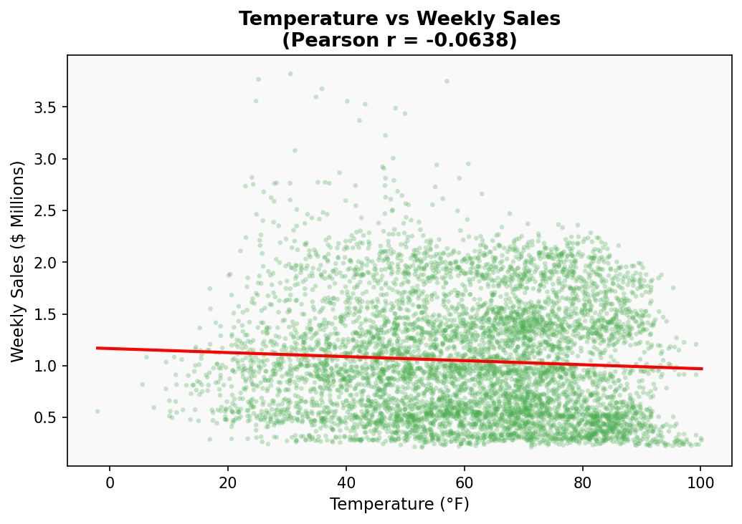
📌 Key Finding
The correlation coefficient of -0.0638 indicates essentially no linear relationship between temperature and weekly sales. This suggests that Walmart's sales are not significantly affected by temperature — customers shop regardless of weather conditions. This makes business sense for a big-box retailer like Walmart, where customers typically drive to the store and purchase a wide variety of goods year-round. The near-zero correlation confirms that other factors (holidays, promotions, economic conditions) are far more important drivers of sales.

Question 9: Relationship between Weekly Sales and Unemployment Rate
The unemployment rate is a key macroeconomic indicator. Higher unemployment typically means less consumer disposable income, which could reduce retail spending. This analysis tests that hypothesis using the Walmart sales dataset.

Metric | Value
Pearson Correlation Coefficient (r) | -0.1062
Interpretation | Weak Negative Correlation
Unemployment Rate Range | 3.68% – 14.31%
Mean Unemployment Rate | ~8.0%
Direction | Higher unemployment associates with slightly lower sales

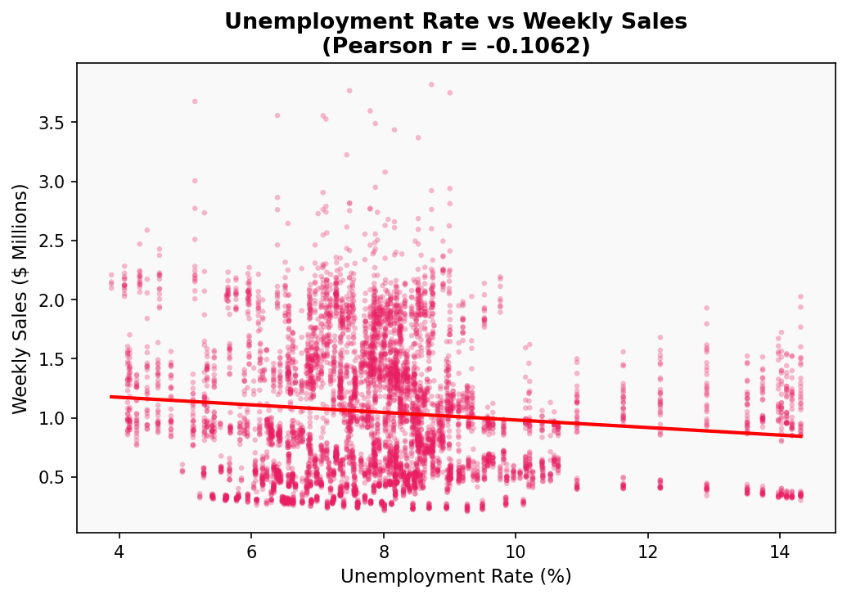
📌 Key Finding
The correlation of -0.1062 shows a weak negative relationship between unemployment and weekly sales — directionally consistent with the economic expectation that higher unemployment leads to lower consumer spending. However, the relationship is weak (r close to 0), suggesting that Walmart is somewhat resilient to unemployment changes. This aligns with Walmart's market positioning as a discount retailer: consumers facing financial hardship may actually shift spending toward affordable Walmart rather than away from it (the "trading-down" effect).

Question 10: Comprehensive Analytics Dashboard
The dashboard below provides a consolidated visual overview of all key analytical aspects of the Walmart Store Sales dataset. It includes sales trends, price indices, fuel price distribution, and all correlation analyses in a single unified view, enabling quick comparisons and holistic understanding of the data.

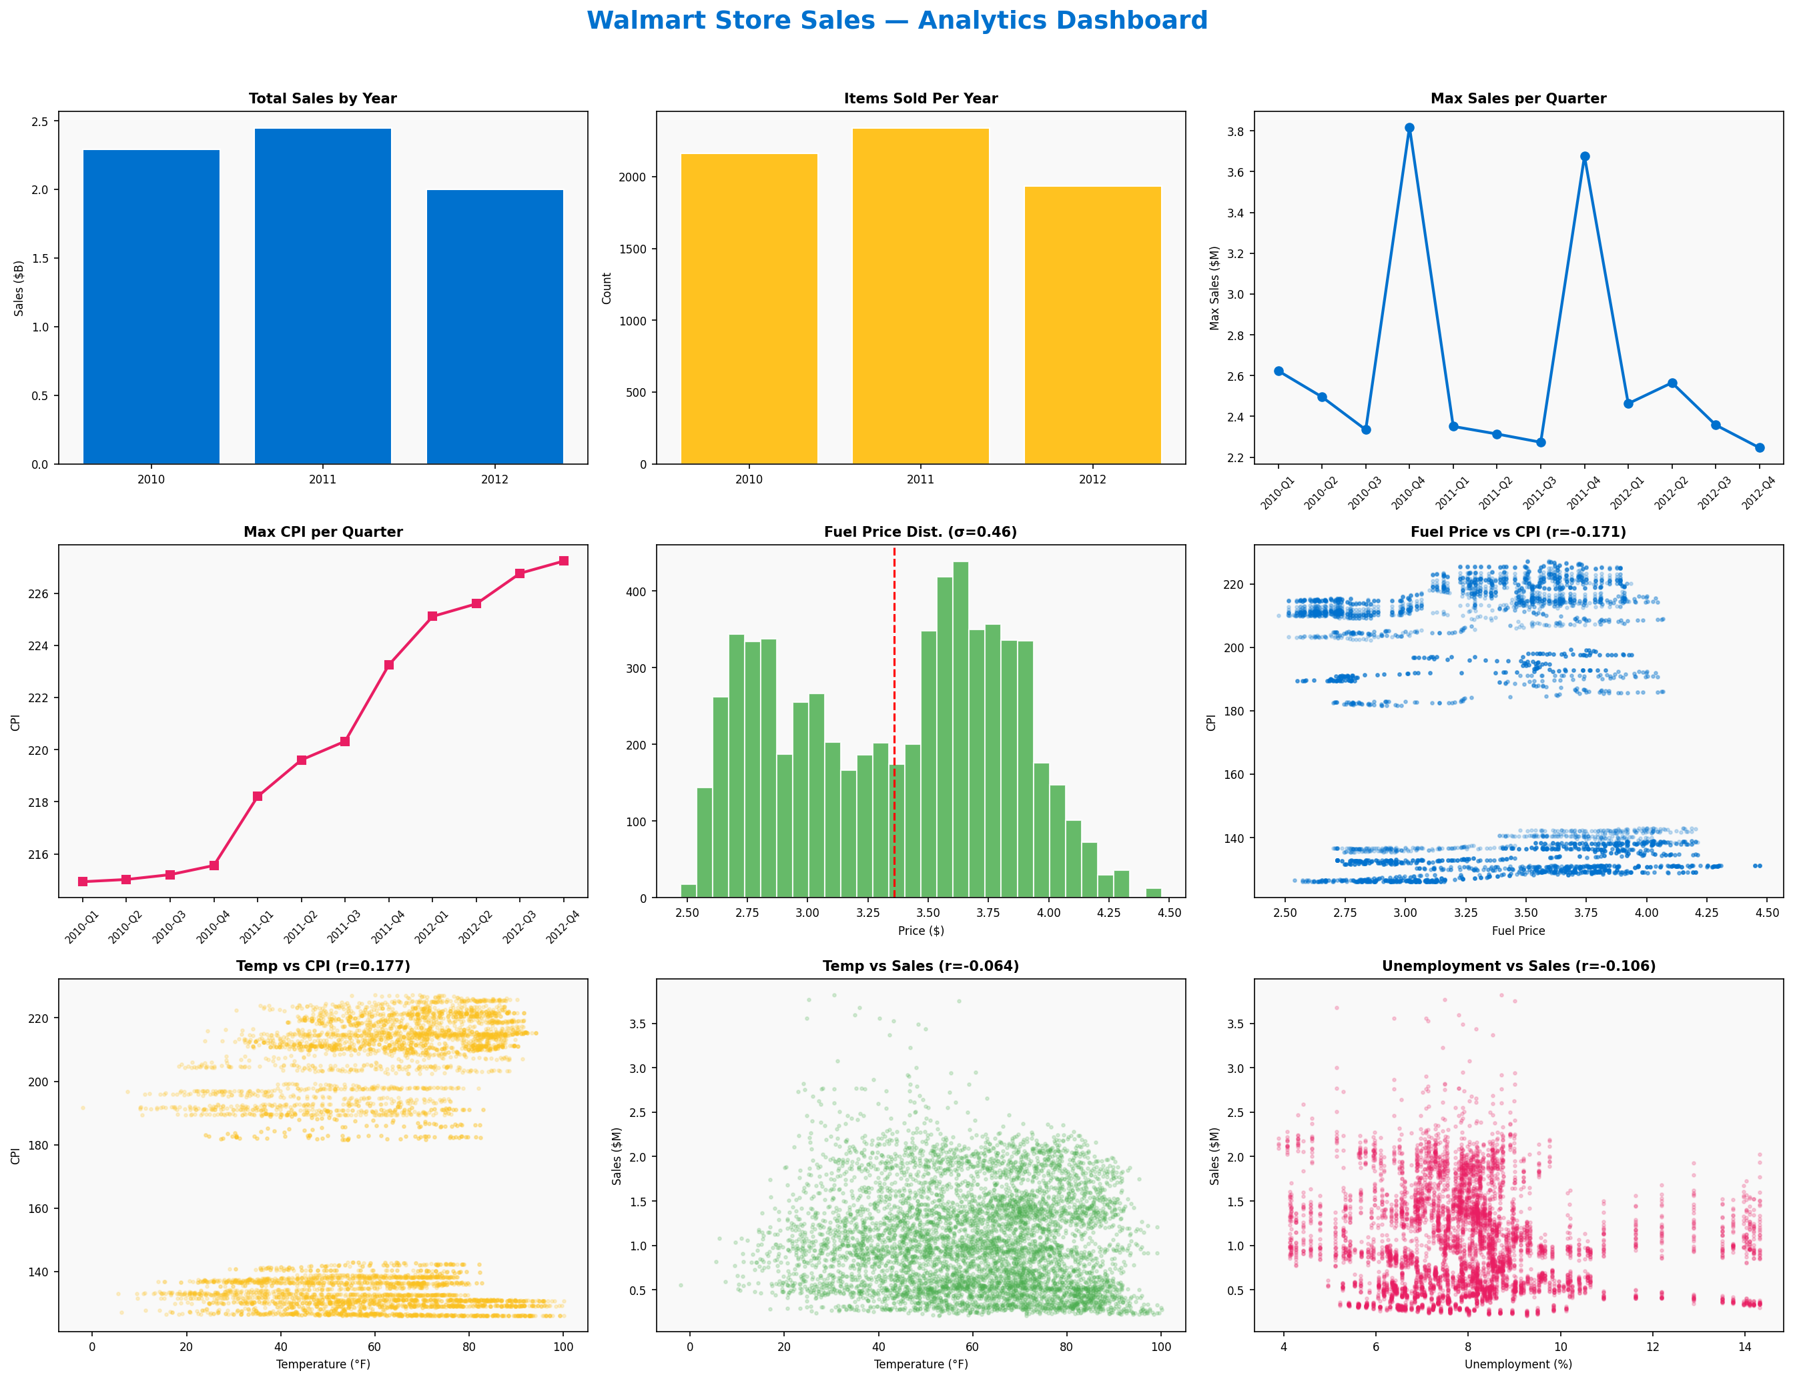

Dashboard Components (Left to Right, Top to Bottom):
- Total Sales by Year — shows 2011 as peak year for total revenue
- Items Sold Per Year — shows record counts per year
- Max Sales Per Quarter — highlights the Q4 holiday season spike
- Max CPI Per Quarter — steady inflation trend across all quarters
- Fuel Price Distribution — bell-shaped with σ = 0.459
- Fuel Price vs CPI — weak negative correlation (r = -0.171)
- Temperature vs CPI — very weak positive correlation (r = 0.177)
- Temperature vs Weekly Sales — negligible correlation (r = -0.064)
- Unemployment vs Weekly Sales — weak negative correlation (r = -0.106)

Summary & Conclusions
This project analysed 6,435 weekly sales records from 45 Walmart stores spanning February 2010 to October 2012. The following are the key conclusions drawn from the analysis:

Analysis | Key Insight
Items Sold Per Year | 2011 had the most records (2,340); all years have complete 45-store coverage
Max CPI Per Quarter | CPI steadily rose from 214.93 (Q1 2010) to 227.23 (Q4 2012)
Max Sales Per Quarter | Q4 consistently peaks due to holiday season (up to $3.82M)
Fuel Price vs CPI | Weak negative correlation (r = -0.171) — largely independent variables
Min/Max Sales Year | 2011 = Maximum ($2.45B), 2012 = Minimum ($2.00B, partial year)
Fuel Price Std Dev | σ = $0.459 — moderate variability around mean of $3.36
Temperature vs CPI | Very weak positive correlation (r = 0.177) — no meaningful relationship
Sales vs Temperature | Negligible correlation (r = -0.064) — sales are weather-independent
Sales vs Unemployment | Weak negative correlation (r = -0.106) — Walmart shows retail resilience

Overall, the Walmart sales data reveals a business that is relatively insulated from macroeconomic factors like temperature, fuel prices, and unemployment. The strongest driver of sales variability appears to be the holiday season (Q4), while long-term sales growth tracks with broader economic trends including CPI increases.

Prepared By:
Ashish

